CCT College Dublin

Assessment Cover Page

Module Title: | Strategic Thinking
Assessment Title: | CA 2 – Capstone Project Proposal
Lecturer Name: | David McQuaid  Dr. Muhammad Iqbal
Student Full Name: | Karina Francieli Schmidt
Student Number: | 2023314
Assessment Due Date: | 02^{h} January 2024
Date of Submission: | 02^{h} January 2024

Declaration

By submitting this assessment, I confirm that I have read the CCT policy on Academic Misconduct and understand the implications of submitting work that is not my own or does not appropriately reference material taken from a third party or other source. I declare it to be my own work and that all material from third parties has been appropriately referenced. I further confirm that this work has not previously been submitted for assessment by myself or someone else in CCT College Dublin or any other higher education institution.

Data Exploration and Analysis in NHANES 2013 – 2014
United States

By

Karina Francieli Schmidt - 2023314

Higher Diploma in Data Analytics for business
Strategic Thinking
David McQuaid
Dr. Muhammad Iqbal
CCT College
Dublin, Ireland

TABLE OF CONTENTS

ABSTRACT 3
INTRODUCTION 5
DATA PREPARATION 7
CONCLUSION 18
DEPLOYMENT 19
REFERENCE 20

ABSTRACT

The National Health and Nutrition Examination Survey (NHANES), conducted by the Centers for Disease Control and Prevention (CDC), constitutes a comprehensive database capturing a wide array of health and nutritional data across a diverse cross-section of the U.S. population. Despite its richness, the dataset's expansive nature may present challenges for targeted analytical endeavors. In this specific sub-dataset, our aim is to enhance analytical precision. This involves the extraction of a refined set of features from the broader NHANES dataset, encompassing physiological measurements, lifestyle choices, and biochemical markers. These selected features have been hypothesized to exhibit robust correlations with age.

The focused sub-dataset holds the promise of revealing nuanced insights into the aging process and its multifaceted determinants. By isolating key variables that are likely to be indicative of age-related changes, we aim to construct a predictive model that refines our understanding of the intricate interplay between various factors and the aging trajectory. This endeavor aligns with the broader objective of leveraging data-driven methodologies to derive actionable insights in the realm of public health. The predictive modeling of age within this sub-dataset not only exemplifies the potential for targeted analyses within large-scale health datasets but also underscores the importance of extracting meaningful information from expansive datasets to inform evidence-based healthcare strategies.

INTRODUCTION

Health is increasingly linked to eating habits and our exercise routine. Especially nowadays, when we have an increasing elderly population and poor eating habits among young people. A balanced diet is essential to avoid the onset of chronic diseases such as diabetes, which involves an increase in sugar in the bloodstream that the body itself cannot metabolise. Practising regular exercise with a healthy diet is one of the ways to avoid the onset of this or other diseases prematurely [1].
This is why government monitoring and research into the health of the population is so important. In this way, it helps to prevent and identify patterns in order to develop more effective strategies that promote public health and improve citizens' standard of living. These practices are the basis for an efficient health system centred on the needs of the population [2].
Analysing data together with the information captured by government surveys is of great importance. By collecting, processing and interpreting it, it is possible for managers to obtain information and make decisions with it. The use of data analysis and machine learning in government surveys related to diseases and health has become a vital tool for gaining valuable insights, improving decisions and driving advances in the area of public health. These technologies offer significant potential for improving the understanding, prevention and treatment of diseases, as well as optimising resource management and policy formulation [3].

Data analysis allows in-depth exploration of massive sets of information, such as electronic medical records, demographic and epidemiological data. With machine learning algorithms, it is possible to identify complex patterns, correlations and trends that can be crucial for predicting outbreaks, understanding risk factors and personalising intervention strategies [4].

In government research, data analysis is often applied to monitor the spread of infectious diseases, model the effectiveness of vaccination campaigns and predict the demand for health services. Predictive models based on machine learning can be used to anticipate the spread of epidemics, allowing for the efficient allocation of resources and the implementation of preventative measures [5].

Furthermore, these technologies play a crucial role in discovering biomarkers, identifying genetic patterns and ensuring the development of personalized treatments. Data analysis allows researchers to identify risk groups, understand the effectiveness of specific treatments, and personalize interventions based on individual patient characteristics [6].

In the government context, ethical and secure implementation of these technologies is essential to ensure the privacy of patient data and promote public trust. As healthcare research becomes more data-driven, it is imperative that policies adapt to protect the interests of individuals while leveraging the full potential of data analytics and machine learning [5].

Integrating data analytics and machine learning into government disease and health research provides an innovative and effective approach to addressing the complex and urgent challenges affecting population health, enabling innovative advances in disease prevention, treatment and management.

DATA PREPARATION

For this project, the dataset that was chosen is named “NHANES”, e um survey desenvolvido entre os os anos de 2013 e 2014 pelo Centers for Disease Contrl and Prevention (CDC), specifically through its National Center for Health Statistics (NCHS), e foi created to assess the health and nutritional status of adults and children in the United States.
Using the “.head” function, the first rows of a dataframe can be quickly accessed to understand the dataset. In this case, the first five rows of it were selected to show.
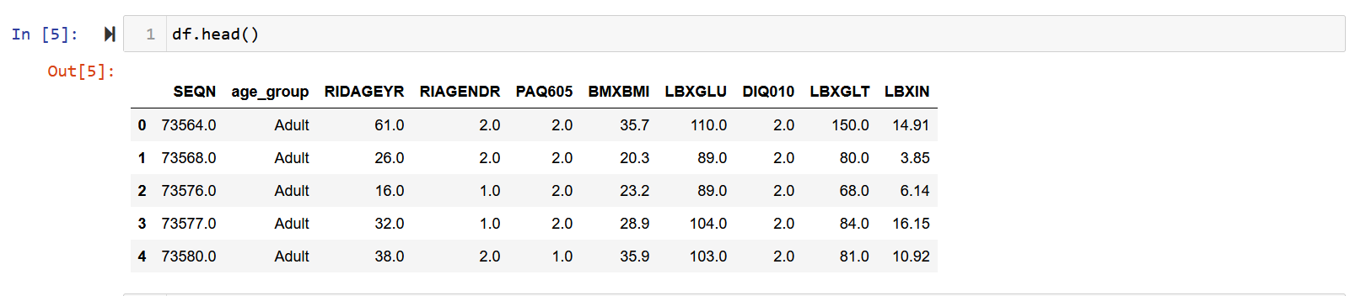
Figure 1 - Head of the dataset

Using the ‘.shape’ and ‘.info’ functions, é possivel ver o tamanho do data set, que conciste em 2278 row and 10 collumns, only one column are represented by ‘object’ data type, and 9 column with numerical data, being consisted of float64 type (approximate numerical values with fractional components).
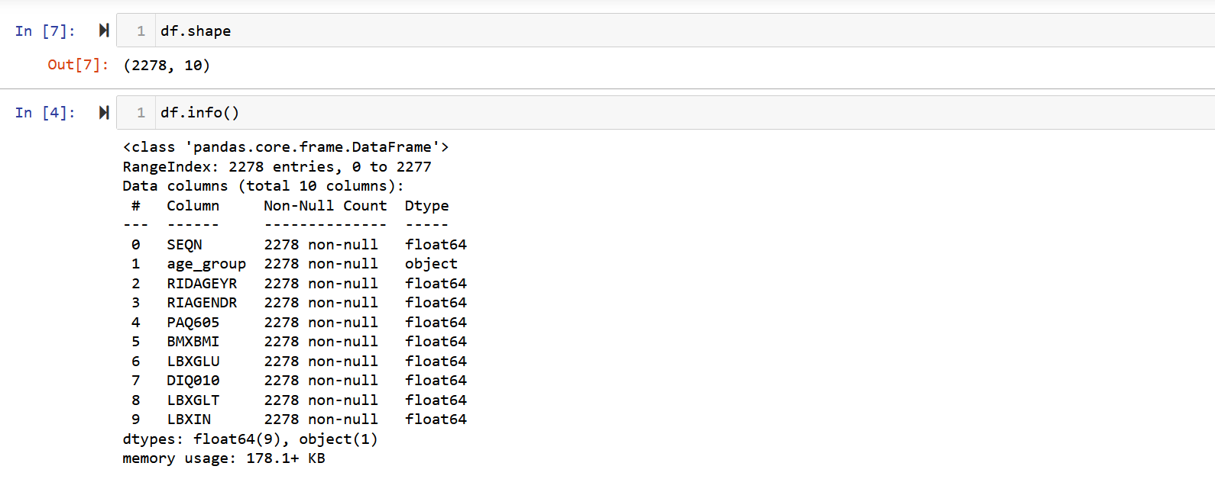
Figure 2 - Shape and info dataset

In this case below, the code was used to check for missing values, but this dataframe has no missing values, as we can see when we apply '.head' and it is also confirmed with the graph (Figure 4).

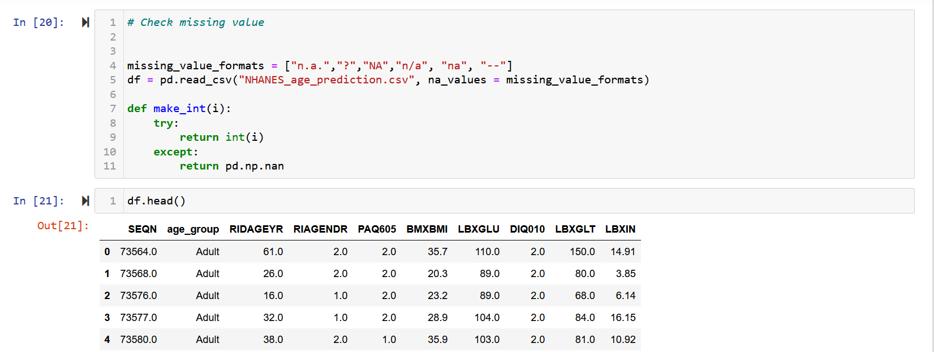
Figure 3 - Code for missing values and head

In figure 4, for better visualisation, the bar chart shows that there are no missing values in any of the columns, as they are all equally aligned.
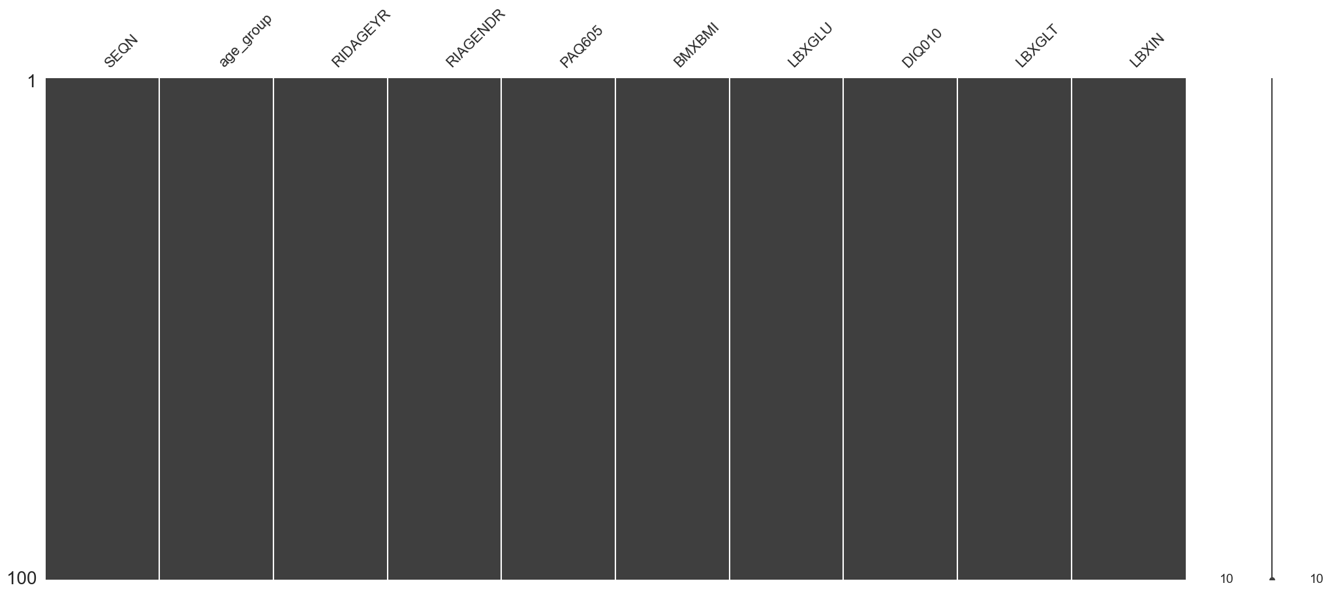
Figure 4 - Missing values

The '.drop' function (figure 5) can be used to remove a column or row from the dataframe, in this case the 'SEQN' column was removed as it only represented the number of each survey.
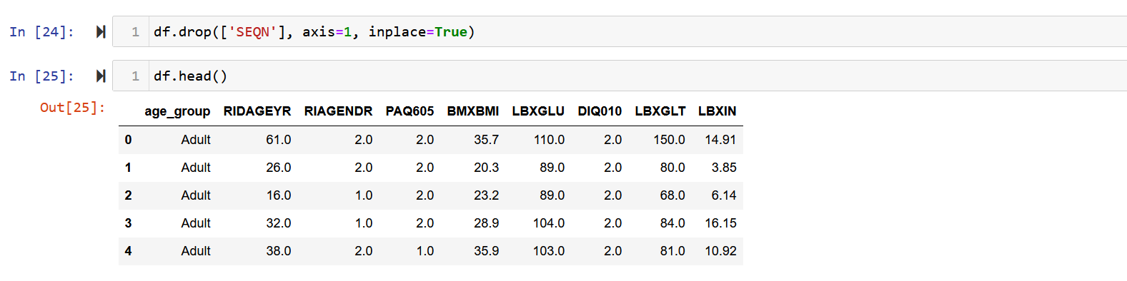
Figure 5 - Drop column

The next step was to use '.rename(columns={.....}, inplace= True)', which renames the required columns, making it easier to understand each one. After the columns have been renamed, '.describe()' is used to summarise the statistics of the dataframe, thus helping to understand the distribution of the data.

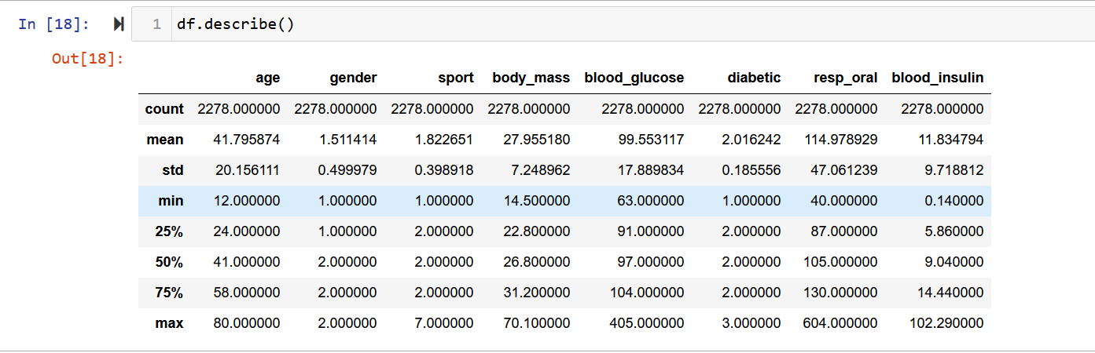
Figure 6 - Describe dataset

In Figures 7 and 8 below, with the box plot, we can visualise the main aspects of the distribution and variability of the data, the average and the extreme values (outliers). In this dataframe, the column with the greatest interquartile variation was age, while the others had little interquartile variation. This distance between quartiles is what shows us the dispersion of the data: the bigger the box, the greater the variation. The better the box, the less dispersion there is between the data. It's also possible to see the number of outliers in almost all the groups, which are identified by the dots on the graph, meaning that there are a number of discrepancies in relation to the average. The features that suffered most from outliers were resp_oral and blood. For the gender, sport and diabetic groups there was no such variance, as the data was identified with the numbers 1 and 2.
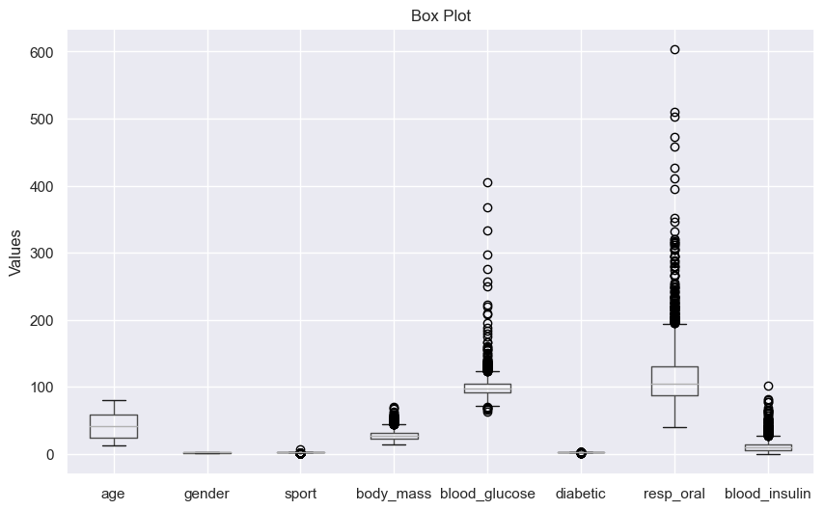
Figure 7 - Statistical summary

Outliers are a major problem for data analysis, as they can affect the values of the average and thus not be very representative. These extreme values are unable to represent the data set, which can lead to erroneous data.

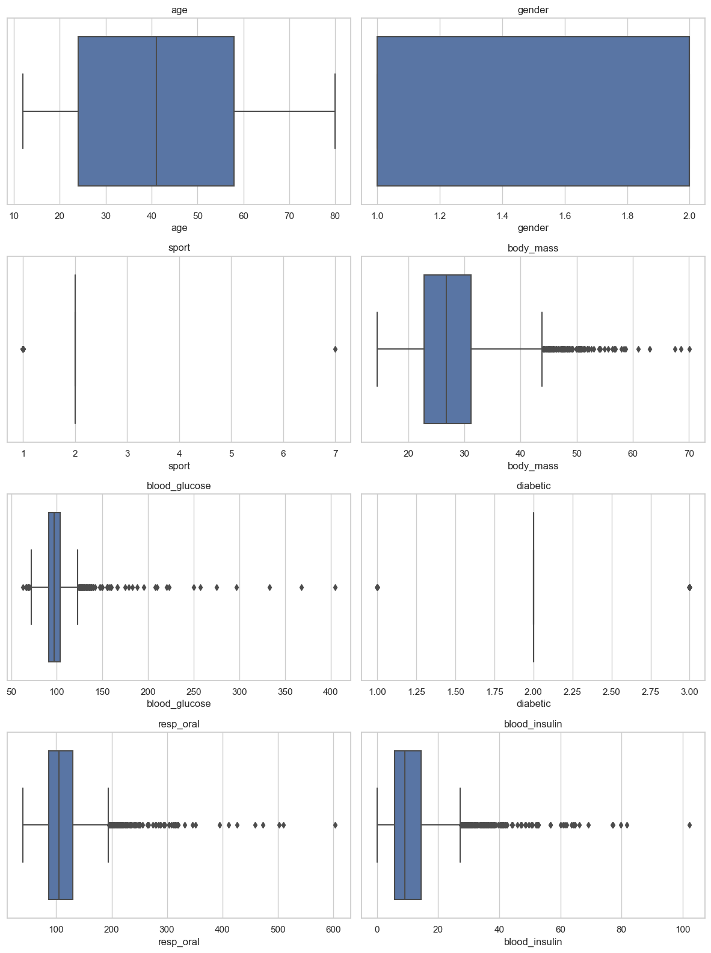
Figure 8 - Summary statistics for each item
In figure 9, after applying LDA (Linear Discriminant Analysis), the data is practically all grouped together and we also have some outliers, most of which are lower values. This could mean that the model didn't work well in this case, with no strong grouping of each feature.

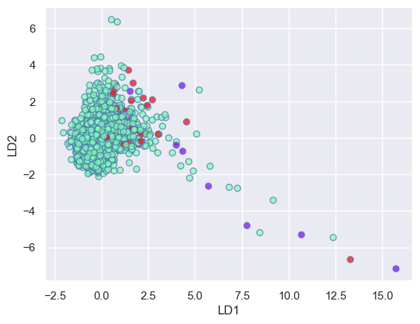
Figure 9 - LDA distributiton

In the next graph we can see a comparison of LDA with and without shrinkage, the difference in accuracy between the two is minimal, approximately 0.01. LDA with shrinkage varied between 0.964 and 0.952, while LDA was slightly higher at 0.964 and 0.959.

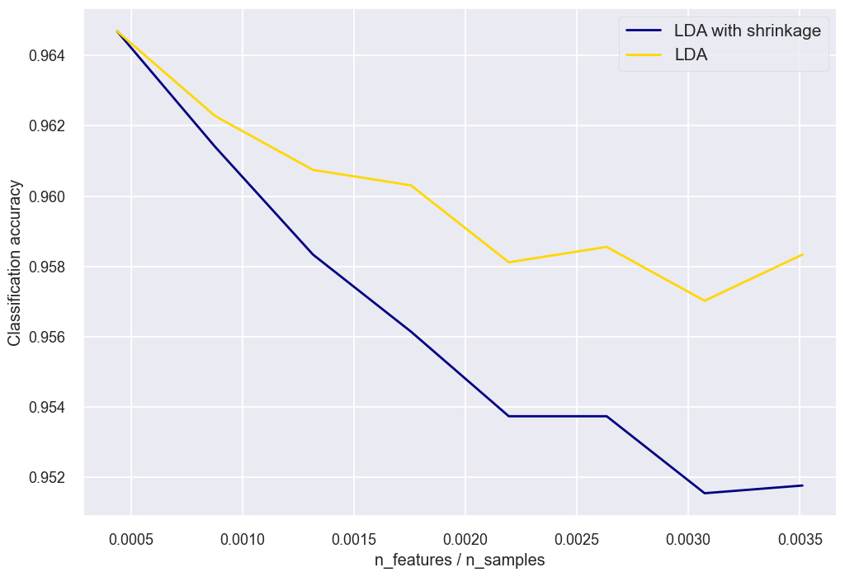
Figure 10 -LDA Comparison

Starting the tests for applying PCA Principal component analysis class scikit-learn plots the variance versus the number of components (figure 11). This plot explains and visually helps us decide on the number of components needed to apply the model. In this case, we can see that the graph becomes stable (forming a straight line) from the fourth component onwards.
We therefore chose to use four components out of the ten in this datafile to apply the model.

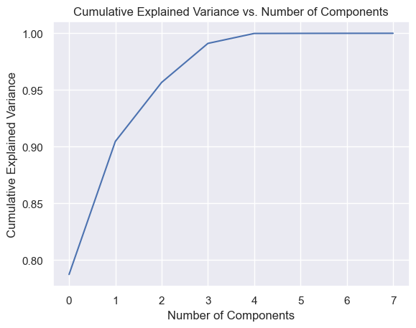
Figure 11 - PCA number of components

In figure 12, after performing the PCA model, we can see a similarity in the graph with the LDA, as all the features are also grouped together and have outliers, but in this case with higher values. Both techniques have the same purpose, which is to reduce dimensionality in data analysis and machine learning. However, each has its own characteristics, with PCA compressing the data, while LDA maximises the separation between classes.
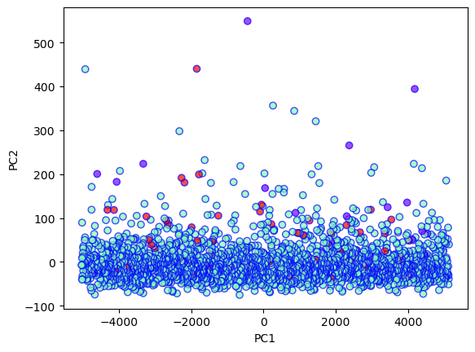
Figure 12 – PCA

In figure 13, comparing LDA and PCA, it can be seen that both had a strong grouping of all the classes, with the presence of outliers. LDA showed lower values for outliers. LDA, being a supervised technique, suffers more from the presence of outliers in the data set, directly impacting on the averages. PCA, on the other hand, does not take class information into account, so it suffers less impact, unless they are extreme outliers, which can affect the variance.

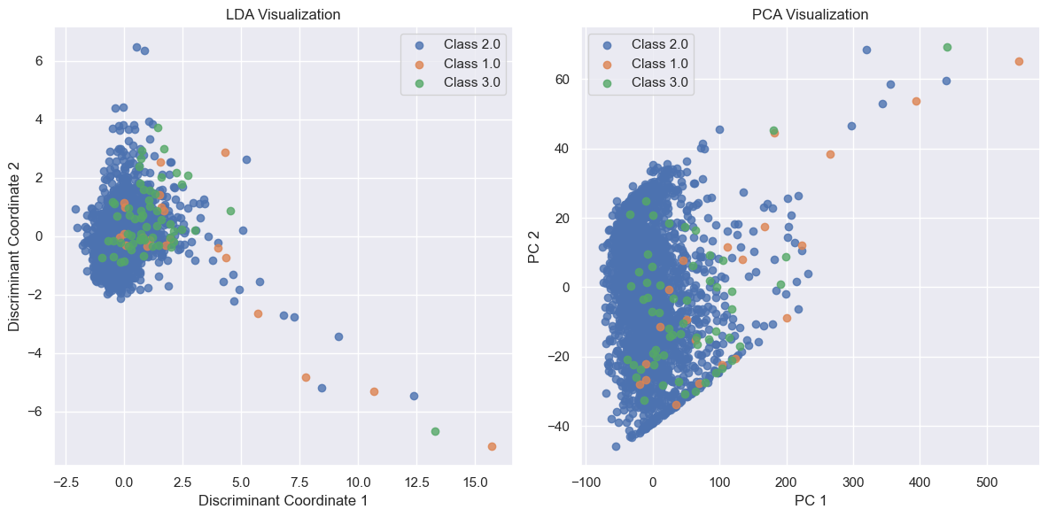
Figure 13 - Comparison LDA x PCA

After using PCA and LDA to reduce the dimensionality of the data in the dataframe, a machien learning Decision Tree Classifier was applied, which divides the data into subsets forming the structure of a tree. The accuracy for this data set was 96%, which means that the model classified the dataframe well.
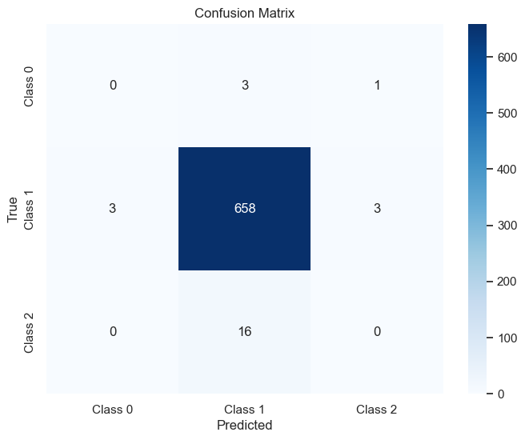
Figura 14 - Consufion Matrix – DTC

The Confusion Matrix is a tool for analysing the performance of algorithms as incorrect or correct. Figure 14 shows the Confusion Matrix for the Decision Tree Classifier. Only in class 1 were there any correct predictions, 658, while in classes 0 and 2 there were no correct classifications.
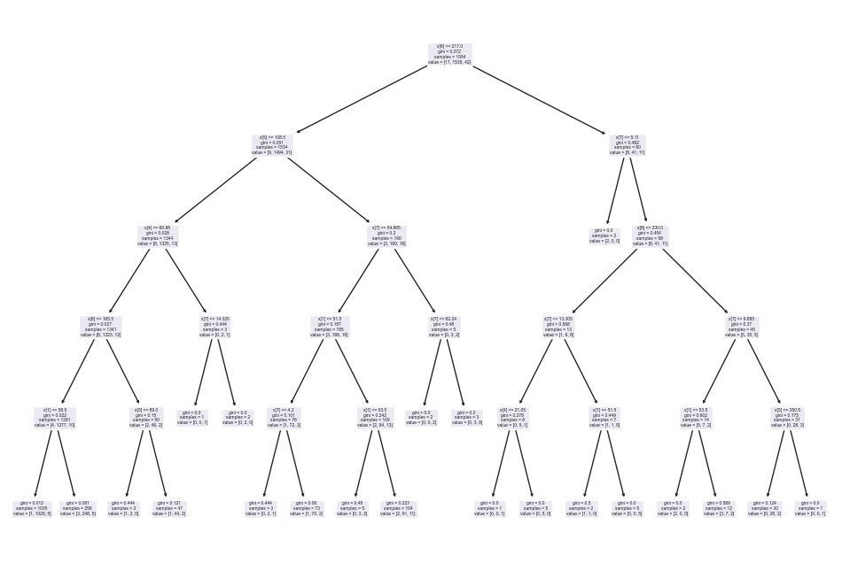
Figure 15 - Decision Tree Classifier

Figure 15 above shows the Decision Tree Classifier of the dataframe used in this assessment. And below, the other tree rezuded after the Grid Search test. For both Decision Tree Classifier and Grid Search, the 'max_depth=3' function was used, which aligns the maximum depth of the decision tree of the dataframe tested during the search in grid 3.

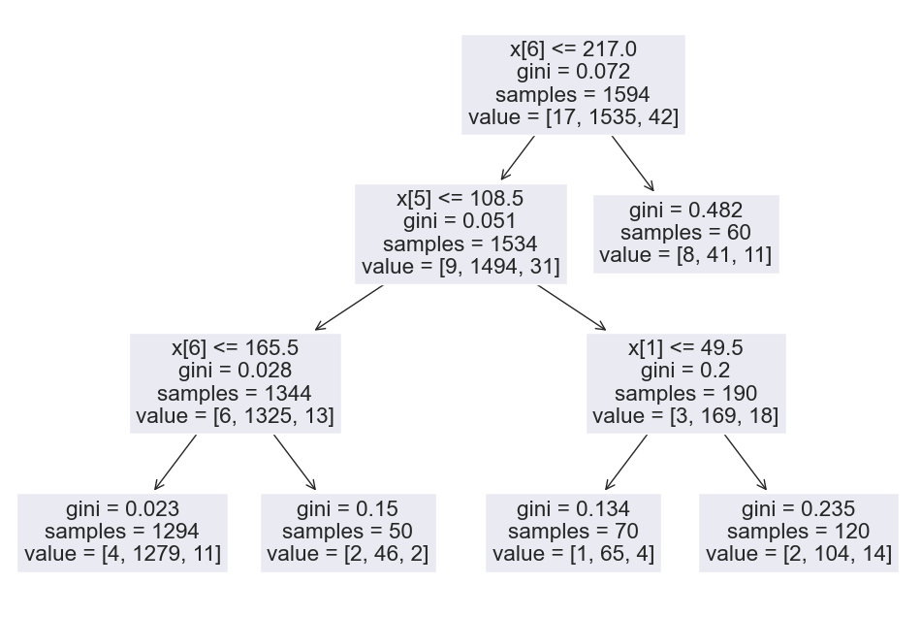
Figure 16 - Grid Search (reduce)

The depth means the distance between the root of the tree and the leaves, militating against overfitting the model. When performing the grid search, Grid Search will test all possible combinations of these values and provide the hyperparameters that produce the best performance within the defined constraints.

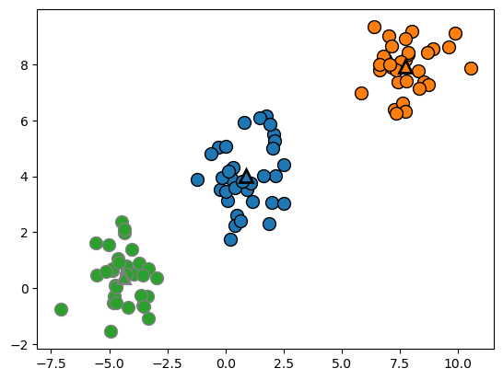
Figure 17 - K-Means

Figure 17 below shows the scatter plot of a clustering model. The dots are coloured according to the clusters assigned by K-Means, and the centres of the clusters are marked with triangles. The triangles represent the centre of a cluster based on its proximity to those centres. From this graph, we can understand how the data is grouped together.

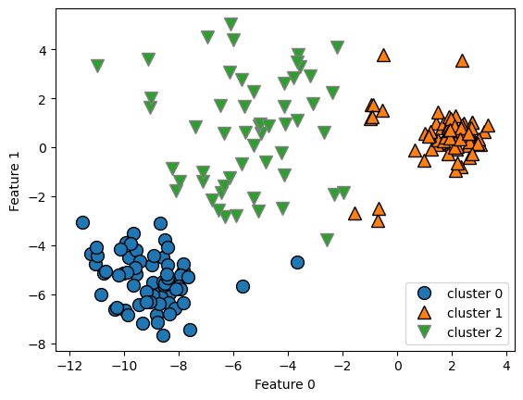
Figure 18 - K-Means Comparison

The figure abose (figure18), this is also a comparison chart for a comparative visualization of K-Means results with 2 clusters and 5 clusters. This way, we can observe how different numbers of clusters can influence the way the clustering algorithm divides the data.

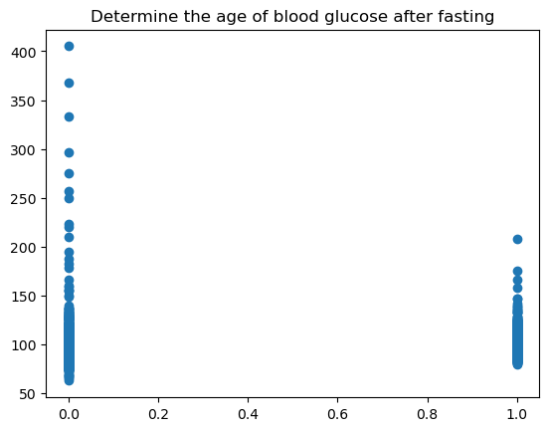
Figure 19 - Age X Blood Glucose
Silhouette Score evaluates whether the method used is grouped in a cluster model, ranging from -1 to + 1. When applied to this model, the value found was 0.567, which indicates a high value, thus showing that there was a good clustering structure in the data analysed. We can say that the objects have been assigned to their clusters.

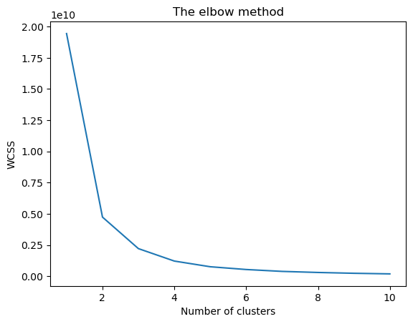
Figure 20 - Elbow Graph

When visualising these values (figure 20), there is a sharp decrease up to approximately 3 clusters. After this point, the decrease in inertia is more gradual, forming an elbow in the graph. Therefore, using the elbow method, you can suggest that the optimum number of clusters for your data is 3 or 4, as adding more clusters does not result in a significant reduction in inertia. The interpretation is made by looking at the point on the graph where the reduction in inertia begins to decrease sharply, forming an elbow, indicating that this number of clusters is a reasonable choice for your data set. However, as well as looking at the graph, you should analyse the data set and which analyses will be discussed.

CONCLUSION

By exploring the issues related to the National Health and Nutrition Examination Survey (NHANES) codes and dataset, it was possible to gain a deeper understanding of the analyses and techniques applied. The use of the K-Means algorithm for clustering, exemplified by the comparative scatter plot with two and five clusters, made it possible to clearly visualise the groupings in the data. The analysis was extended to evaluate the Silhouette Score, revealing a value of 0.567, indicating a solid clustering structure and an effective assignment of objects to their corresponding clusters.
In the context of NHANES, the creation of a focused subset, as evidenced in the predictive modelling of age with specific characteristics, highlights the potential for detailed insights into the ageing process and its multifaceted determinants. Careful consideration of metrics such as accuracy and Silhouette Score illustrates the rigorous approach to evaluating models and validating results.
These explorations not only highlight the practical application of analytical techniques to complex datasets, but also emphasise the importance of data-driven approaches in gaining valuable insights in the public health domain. The answers provided seek not only to resolve specific queries, but also to promote a broader and more effective understanding of the nuances present in NHANES data.

DEPLOYMENT

Every AC for me is a big challenge, and I often feel insecure when doing it alone. I feel like I need someone to discuss and share how the path should be taken after carrying out data understanding and data cleaning, as I still have doubts about the best way to apply machine learning. I still can't identify if I'm doing it right and sharing it into a team becomes easier. Even though the classmates are working on the same dataset, it seems that each one follows a different path. And I also still see a difficulty in explaining graphics, in a clear and well-explanatory way. But I see that I had a small evolution from the beginning in September until the month of December.

REFERENCE

1- Ogunyemi, O.I. et al. (2021) ‘Detecting diabetic retinopathy through machine learning on electronic health record data from an urban, safety net healthcare system’, JAMIA Open [Preprint], (3). Available at: ttps://search.ebscohost.com/login.aspx?direct=true&db=edssch&AN=edssch.oai%3aescholarship.org%3aark%3a%2f13030%2fqt6v07w9d3&site=eds-live&scope=site (Accessed: 24 December 2023).
2 - Krieger, N. et al. (2003) ‘Race/Ethnicity, Gender, and Monitoring Socioeconomic Gradients in Health: A Comparison of Area-Based Socioeconomic Measures—The Public Health Disparities Geocoding Project’. Available at: https://search.ebscohost.com/login.aspx?direct=true&db=edsuph&AN=edsuph.990&site=eds-live&scope=site (Accessed: 22 December 2023).
3 - Peter Langkafel (2016) Big Data in Medical Science and Healthcare Management : Diagnosis, Therapy, Side Effects. Berlin: De Gruyter. Available at: https://search.ebscohost.com/login.aspx?direct=true&db=e250xww&AN=1107028&site=eds-live&scope=site (Accessed: 1 January 2024).
4 - Dylan Kneale et al. (2018) ‘How can additional secondary data analysis of observational data enhance the generalisability of meta‐analytic evidence for local public health decision making?’, Research Synthesis Methods, 10, pp. 44–56. Available at: https://search.ebscohost.com/login.aspx?direct=true&db=edsair&AN=edsair.doi.dedup.....201c7a4e6413bac0f972b5f3c8cc9b8b&site=eds-live&scope=site (Accessed: 24 December 2023).
5 - Pouyanfar, S. et al. (2019) ‘Multimedia Big Data Analytics: A Survey’, ACM Computing Surveys, 51(1), pp. 1–34. doi:10.1145/3150226.
6 - Kelsey Chalmers, Valérie Gopinath and Adam G Elshaug (2023) ‘Health service research definition builder: An R Shiny application for exploring diagnosis codes associated with services reported in routinely collected health data’, PLoS ONE, 18(1), p. e0266154. doi:10.1371/journal.pone.0266154.

